**Sound Recorder - Android Application**

Submitted in partial fulfillment of the requirements for the award of degree of

**BACHELOR OF ENGINEERING**

**IN**

**COMPUTER SCIENCE & ENGINEERING**



**Submitted to:**

**Er. Charnpreet Kaur**

**Submitted By:**

**NAME: TARUSH KAISTHA**

**UID: 18BCS2068**

**DEPARTMENT OF COMPUTER SCIENCE & ENGINEERING**

**Chandigarh University, Gharuan**

**June 2021**

**ACKNOWLEDGEMENT**

We express our deep sense of gratitude to our respected and learned guide, **Er. Charnpreet Kaur (Assistant Professor, UIE)** for their valuable help and guidance. We are thankful to her for the encouragement.

We are also thankful to all the other faculty & staff members of our department for the kind cooperation and help.

Lastly, we would like to express our deep appreciation towards our classmates and our parents for providing us the moral support and encouragement.

**INTRODUCTION**

Sound Recorder is an Android Based Application developed using Java programming language. We have also seen inbuilt voice recorders in our smartphones and I have made the clone of the same for gaining the knowledge of Android Development. This application is developed so that all the users could record their voices to become fluent in all languages such as Hindi, English, etc.

**FEASIBILITY STUDY**

**Feasibility Study:**

The feasibility study is performed to determine whether the proposed system is viable considering the Technical, Operational and Economical factors. After going through feasibility study we can have a clear-cut view of the system’s benefits and drawbacks.

**Technical Feasibility:**

The front end of the application is made using various design principles i.e. Object Oriented Designing, wireframes, view hierarchy, layouts, material libraries, etc.

The back end of the application is made using Java programming language, Firebase, Sqlite, etc.

**Operational Feasibility:**

The application is working fine in terms of operational feasibility as the recorder and the media player is working according to the functionality that has been provided. Recorder simply records the voice or sounds of the users and the media player is used to play the audio file.

**Economical Feasibility:**

As the necessary hardware and software are available in the market at a low cost, the initial investment is the only cost incurred and does not need any further enhancements. Hence it is economically feasible. The system is feasible in all respects and hence it encourages taking up the system design.

**Gathering Information:**

The analysis through collection of data plays the wider role in the analysis of the system. So the data is collected at different levels of management to keep track of full information of the system. The collection of data is done from Top Level Management Middle Level Management Low Level Management Different methods used to collect the data:

**METHODOLOGY AND PLANNING OF WORK**

In order to complete this project, we would be following discipline and decorum for perfect completion of the project. Each and every team member has been assigned a task and cooperation of every team member would be taken into consideration.

We have organized a perfect schedule for making the project and we have gathered all the materials required for completion of the project. Our aim is to maximize the productivity of this project by applying concepts of some programming languages that would be used in the project.

The methodology is based on time management, accuracy, well defined goals etc.

**MODULE & DISTRIBUTION OF WORK**

* In this project, I would be making an android application called Sound Recorder which would record the audio of the users using a recorder and these would be played using a media player.
* In this, I am a leader as well as the member so I would be working on both Front End and Back End.
* Front end would be implemented using Design Libraries, Wireframes, Layouts, etc.
* Back end would be implemented using Java, Sqlite, Firebase, etc.

**DESIGN AND MODELING**

In this, the designing and modeling of the project would be done. So, there a various ways in which this can be done.

Some of them are as follows:

* DFD (Data Flow Diagrams)
* UML (Unified Modeling Language)
* Class Diagrams

So, by using the above techniques, we can do the designing of our project & accordingly the code would be obtained. Purpose of this phase is to show the data flow between different components in our project.

Data Flow Diagram:

A data flow diagram shows how data is processed within a system based on inputs and outputs. Visual symbols are used to represent the flow of information, data sources and destinations, and where data is stored. Data flow diagrams are often used as a first step toward redesigning a system. They provide a graphical representation of a system at any level of detail, creating an easy-to-understand picture of what the system does. A general overview of a system is represented with a context diagram, also known as a level 0 DFD, which shows a system as a single process. A level 1 diagram provides greater detail, focusing on a system’s main functions. Diagrams that are level 2 or higher illustrate a system’s functioning with increasing detail. It’s rare for a DFD to go beyond level 2 because of the increasing complexity, which makes it less effective as a communication tool.

|  |  |  |
| --- | --- | --- |
| External Entity | ​ | ​ |
| Process | ​ | ​ |
| Data Store | ​ | ​ |
| Data Flow | ​ |  |

DFD for Sound Recorder:

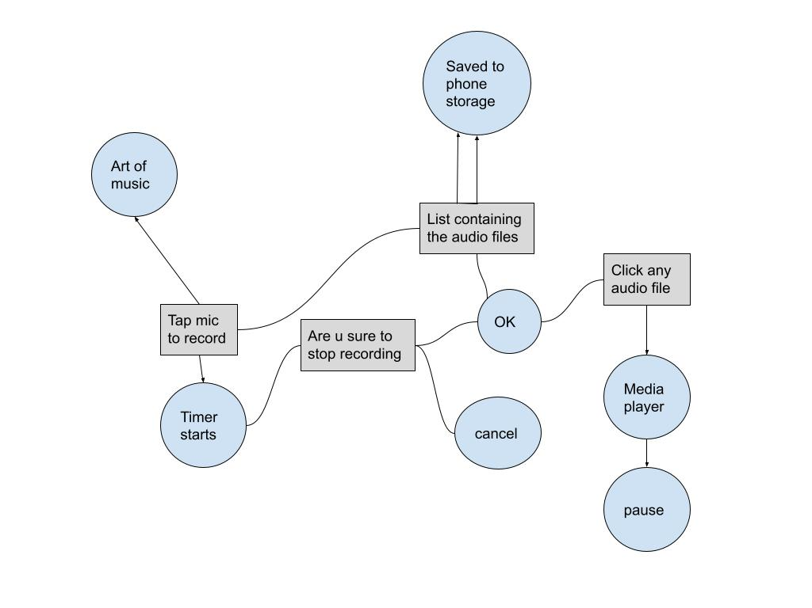

**INNOVATIONS IN PROJECT**

Today, voice recorders are widely used in various applications such as WhatsApp messenger, Facebook Messenger, etc.

There would be two most important innovations in this project:

* When the users would record their voices, then they would only be able to listen to their own audio files & not of other ones. This means that each and every audio file of the users would be encrypted using some techniques such as Cipher, etc.
* At present, there is no provision for sending & sharing the audio files through any FTP, SMTP clients, any social networking website, etc.

**SOFTWARE AND HARDWARE REQUIREMENTS**

**Software Requirements:**

* Ubuntu 20.04 LTS
* Android Studio IDE

**Hardware Components:**

* Processor – i3
* SDD: 240 GB
* Mouse and Keyboard

**BIBLIOGRAPHY**

In order to complete this project, we have referred some books and online links which have been categorized as follows:

* <https://www.youtube.com/playlist?list=PLGCjwl1RrtcQWt6CjKXqK4SoFAd3imSdX>
* Course on android app development through coursera.
* https://www.javatpoint.com/android-tutorial